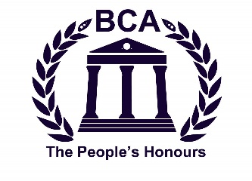
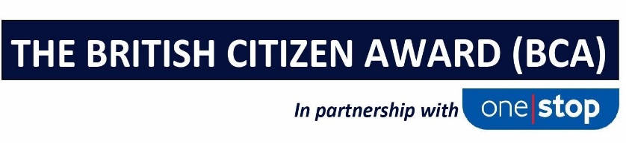
PRESS RELEASE

THE BRITISH CITIZEN AWARD RELEASES JUNE 2023
PEOPLE’S HONOURS LIST

On Thursday 29th June at the Palace of Westminster 26 individuals from around the UK will be awarded the prestigious British Citizen Award for their exceptional endeavours which have positively impacted communities up and down the country.

The 26 making the June 2023 People’s Honours list have all been recognised for making a positive contribution to life in the UK, and sometimes further afield.

The British Citizen Award in partnership with One Stop, is now in its ninth year and recognises an elite group of exceptional individuals twice annually. The June 2023 cohort of medalists each receive the BCA Medal of Honour as a legacy for their commitment to others and richly deserve the right to use the letters BCA after their name in perpetual recognition of the nation’s gratitude. The full list of those being honoured is below:

THE British Citizen Award June 2023 People’s Honours List

Marie Ralph BCAe for Services to Education
Austism champion and trainer, running two charities supporting parents of Autistic children

Akef Akbar BCAe for Services to Education
Supporting and promoting inter-racial harmony through educating hard-to-reach communities

Gary McKee BCAc for Services to the Community
Raising over £2million over 20 years and encouraging an active lifestyle to over 1500 in the local community

Joyce Nicoll BCAv for Services to Volunteering & Charitable Giving
Charis Charity founder and volunteer for 30 years, providing a much-needed resource to the community

Peter Whittingham BCAc for Services to the Community
Community hero and village milkman of 46 years helping to protect the vulnerable and reduce isolationism

Monju Meah BCAv for Services to Volunteering & Charitable Giving
Dedicated foodbank volunteer for 15 years who has raised over £300,000

Dawn Murray BCAh for Services to Healthcare
20 years supporting those suffering ‘disenfranchised grief’ after pet bereavement

Edward (Eddie) Lewis BCAc for Services to the Community
Supporter of three children’s charities for 40 years raising almost £5 million

Ram Prakesh Gupta BCAe for Services to Education
Provided IT equipment to thousands of underprivileged families to better their education

Heather Prangley BCAc for Services to the Community
13 years creating a more harmonious neighbourhood engaging different communities

James Anderson BCAv for Services to Volunteering & Charitable Giving
Providing free services for the elderly and vulnerable living in fuel and food poverty

Jeewan Kala Gurung BCAhon for Services to the Community
Creator and trainer for counselling services to the Gurkha community reaching thousands

Michael Thomas Hampton BCAc for Services to the Community
'Mike on a Bike' creator of Local Larder delivering food and essentials to those in need

Damien Reynolds BCAv for Services to Volunteering & Charitable Giving
Founder of a mental health support charity for young people suffering loneliness

Angie Sutcliffe BCAo for International Achievement
Actively raising morale of children in Ukraine and supporting the relief effort

Chris Kapnisis BCAc for Services to the Community
Church leader raising £13million to rebuild and re-design a community asset in Dagenham

Keith Grainge BCAc for Services to the Community
Created a fitness group for over 70's promoting positive mental and physical health

Lesley Allen BCAc for Services to the Community
22 years supporting elderly African-Caribbean residents in inner city London

Mark Milligan BCAe for Service to Education
Creator of the largest dedicated educational platform for archaeology and anthropology globally

Peter Edwards BCAv for Services to Volunteering & Charitable Giving
50 year RNLI volunteer dedicated to saving lives at sea and promoting the 200 year-old charity

Elizabeth (Libby) Ranzetta BCAc for Services to the Community
Co-Founder of Bury St Edmunds Rickshaw, offering free rides to those with limited mobility and social isolation

Gemma Ellis BCAv for Services to Volunteering & Charitable Giving
Founder of ‘Stage 4 Deserves More’ and ‘The Gem Foundation’ providing funding for research

Dr. Muhammad Nasti BCAo for International Achievement
Founder Mothers Helpage UK, aiding humanitarian disasters in over 20 countries globally

Terry Woods BCAv & Barbara Woods BCAv for Services to Volunteering & Charitable Giving
Dynamic duo who raised over £450,000 for multiple charities and supporters of the Anne Conroy Trust

Tyler Murphy BCAv for Services to Volunteering & Charitable Giving
Creator of 'Tylers Trust' to provide toys for children being treated for long-term and complex health issues

The British Citizen Award was established in 2015 to recognise exceptional individuals who work tirelessly and selflessly to make a positive impact on their communities and society. The BCA recognises true community heroes who would otherwise likely be overlooked. Dubbed ‘The People’s Honours’, the BCA has so far recognised over 500 exceptional individuals for their divergent endeavours, making them a very exclusive group of the nation’s favourites.

Anyone with an MBE, OBE or Knighthood is ineligible for a BCA having already been deemed to have received recognition, however, anyone receiving the BCA can still be nominated for the other honours. Nominations can be made a www.britishcitizenawards.co.uk. Whilst the programme is currently operating nationwide in the UK, negotiations for licensing the programme in overseas territories including the US, Australia, Canada, UAE, India & Spain are ongoing.

***ENDS***

Date of issue: 15th June 2023

For more information, please contact press@britishcitizenawards.co.uk or call 0203 002 7764.

Notes to Editors

The British Citizen Award recognises individuals that positively impact others and highlights the positive
aspects of multi-cultural communities, workplaces, community groups and charities throughout the UK. It is accessible to all and serves to celebrate the good things that make Britain great.
There is no fee for making a nomination. Nominees who are granted a BCA will be invited to attend the
Presentation Day at the Palace of Westminster. Presentations are held twice annually in January and July (June this year for operational reasons).

The full list of categories for the British Citizen Awards are:
BCAc for Service to Community
BCAi for Service to Industry
BCAa for Service to Arts
BCAe for Services to Education
BCAh for services to Healthcare
BCAb for Service to Business
BCAv for Volunteering & Charitable Giving
BCAo for International Achievement

The full list of supporters include:
One Stop
Specsavers
Places for People
Objective HR
Uniserve
Big Bus London
Tigerbond

